Introduction
Artificial intelligence is now central to business and decision support. As integration accelerates, organisations face challenges in enabling access, protecting data, managing models, ensuring accountability, controlling costs, and meeting compliance requirements. Together, these lead to a critical question: how can AI infrastructure remain secure and governable across organisational, technical, and regulatory domains?
The scientific literature and relevant standards suggest that governance expectations differ across AI systems, sectors, and use cases. Three recurring challenge areas can be identified. First, from a governance perspective, unclear accountability structures and weak ownership can create gaps between formal policies and operational practice. Addressing these gaps requires assigned responsibilities and clear decision-making authority (Mäntymäki et al., 2022). Second, from a risk management perspective, AI-related risks must be managed throughout the full system lifecycle. This includes appropriate controls, monitoring mechanisms, and certification or assurance processes across development, deployment, and operation (Brogle et al., 2025; Korobenko et al., 2024; Mökander & Floridi, 2023). The literature further highlights the value of adaptive governance approaches, especially for enabling risk tiering, targeted approvals, and continuous improvement in various sectors and application contexts (Ebere-Uneze & Naqvi, 2024; Heger et al., 2025; Reuel et al., 2025; Szadeczky & Bederna, 2025). Third, from a compliance perspective, existing standards and frameworks address AI risk in different ways and at different levels of specificity. NIST AI RMF 1.0 is designed for AI risk management (NIST AI RMF 1.0, 2023). In contrast, NIST CSF 2.0, ISO/IEC 27005, and NIST SP 800-53 provide broader guidance on cybersecurity, information-security risk management, and security and privacy controls (ISO 27005, 2022; NIST CSF 2.0, 2024; NIST SP 800-53r5, 2020). Additionally, EU regulations introduce legal requirements related to transparency, accountability, documentation, and evidence-based governance (EU AI Act, 2024; EU Data Act, 2023). These sources indicate that no single framework is sufficient. Instead, organisations need to integrate multiple governance, risk, and compliance instruments to establish a coherent approach to AI oversight.
This paper focuses on a business-to-business software-as-a-service handling sensitive data. It aims to offer customers a secure cloud integration while customers maintain control of sensitive data, AI operations, compliance and resilience. This is done through a shared functional Defence-in-Depth (DiD) viewpoint, with additional viewpoints such as organisational and technical networking as extensions (ISO 42010, 2022). One can see this as a collaborative governance, risk and compliance (GRC) between the customer and the service provider.

Conceptualization of a secure IT-infrastructure
The business model for the AI cloud provider is business-to-business software-as-a-service with optional customer-specific constraints. Security governance consists of a constellation based on a System of Systems (Maier, 1998). Key features include a unified AI gateway, governance dashboards, regulated agent access, customer data isolation, continuous compliance reporting, and central cost tracking.
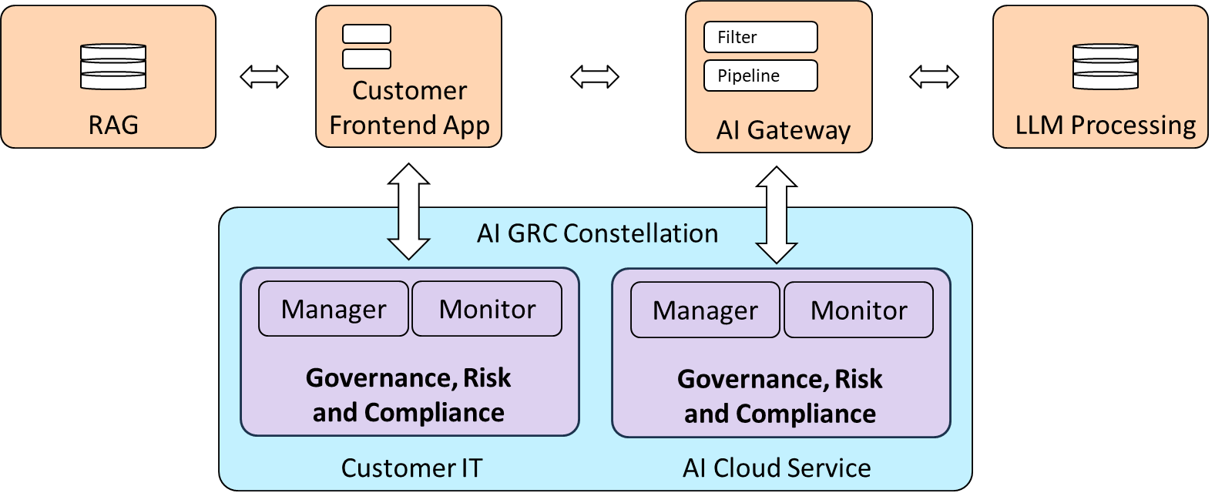
Figure 1 presents the overall design. The key architectural choice is to place an AI Gateway between users’ applications, and external LLM models. This creates a technical enforcement point where usage is actively controlled in real time. It also provides a policy and monitoring point for the AI GRC approach between customer and service provider.
Figure 1, Overview of secure IT-infrastructure for a medium-sized AI cloud services
The proposed concept is focused on a medium-sized cloud provider developing AI-enabled cloud services. It builds software, uses cloud platforms for development and testing, and runs customer services on customer-selected infrastructure. AI patterns include coding assistants, customer retrieval-augmented generation (RAG), and agentic pipelines and workflows using a defined list of LLM-supported services.
Both provider and customer data need to be separated for protection, including personal information, business data, regulated records, source code, contracts, and logs.

Detailed secure IT-infrastructure
The detailed design follows a DiD pattern using multiple, independent layers of security so that if one fails, others remain effective. It assumes no single control can fully prevent misuse, data leakage, or operational failure. Instead, each layer reduces risk and provides detection or recovery when another layer fails.
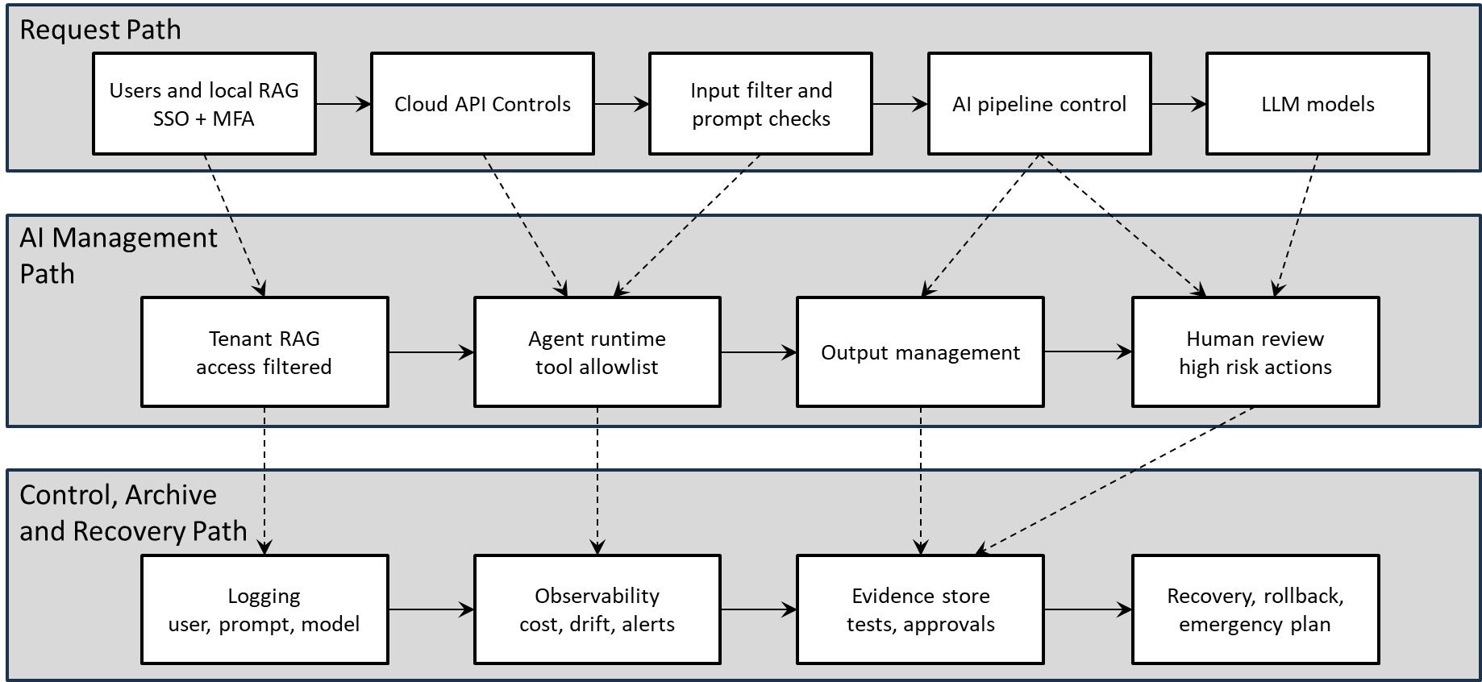
Figure 2 shows the detailed layers of the AI GRC constellation. The design is intentionally generic so it can be implemented with different IT infrastructure and AI providers. The core principle is fail-closed enforcement. Requests are allowed only when the user, tenant, data classification, model, region, and purpose satisfy the policy. Otherwise, the request is blocked, logged, or escalated for review. The architecture can be understood through three paths: 1) The Request Path, 2) The AI Management Path, and 3) the Control, Archive and Recovery Path.
Figure 2, Detailed cloud service DiD based on three separate management paths
The table below translates the AI GRC challenges into a set of practical management and control functions. The controls are organised around key areas, outline selected functionality, and explain how they contribute to accountable, risk-based, and evidence-driven AI governance.
Management and Control | Selected functionality | Motivation
Governance and risk ownership | AI governance, named system owner, risk owner, data owner and model owner for each AI use case. | The literature identifies unclear accountability as a key weakness. Named ownership makes risk acceptance, review and incident response possible.
Use-case intake and risk tiering | Every AI use case is registered with purpose, data types, model/provider, affected users, risk level and required approvals. | Different AI applications have different risk profiles. Risk tiering prevents low-risk controls from being overused and high-risk controls from being missed.
Identity and access management | SSO, MFA, conditional access, privileged access management, just-in-time admin access and role-based access to AI tools. | Prevents uncontrolled AI use and supports traceability. Least privilege limits damage from compromised accounts.
Network segmentation and private connectivity | Separate development, test, production, management and logging networks. Private endpoints for data stores and restricted egress to approved AI providers. | Reduces lateral movement and prevents direct data exfiltration to unapproved services.
AI Gateway | All AI requests from applications, APIs and developer tools pass through a gateway for authentication, policy checks, routing, rate limiting and logging. | Provides a central enforcement point for fragmented AI usage, matching the generic gateway business cases.
Data classification and DLP | Classify prompts, documents, code and customer data. Redact or block PII, secrets and confidential data before external model calls. | Sensitive data must not leave the trust boundary unless allowed by policy and contract.
Prompt and tool security | Prompt injection detection, system prompt protection, tool allowlists, output constraints, sandboxing and secrets isolation for agents. | Agentic AI increases the risk of indirect prompt injection and unauthorised tool use.
Model and provider approval | Approved model catalogue with provider security level, data residency, retention policy, SLA, cost profile and allowed data classes. | Ensures confidential data is routed only to approved models and regions.
Secure SDLC and CI/CD | Code scanning, dependency scanning, IaC scanning, signed builds, separation of duties and deployment approvals. | Protects the software supply chain and makes AI services repeatable across cloud providers.
Monitoring, SIEM and dashboard | Real time monitoring of prompts, outputs, policy violations, usage, costs, model versions, incidents and anomalies. | The literature emphasises the gap between policy and practice. Monitoring turns policy into operational control.
Audit evidence and documentation | Store model cards, test reports, human approvals, prompt templates, risk decisions, incident records and changes. | Supports auditability, certification-like assurance and regulatory reporting.
Backup, recovery and resilience | Immutable backups, tested restores, cross-region replication, break-glass access, rollback of model versions and incident playbooks. | Protects availability and integrity in case of ransomware, provider outages, model failure or misconfiguration.

The above functions and layers describe their contributions to DiD, providing a structural view for management and monitoring of the AI Gateway.
Long-term security depends on lifecycle management. Model versions, prompts, embeddings, tools, APIs and provider contracts change frequently. The service organisation must therefore maintain an AI asset inventory, a model catalogue, a prompt repository, a risk register and a control mapping. Periodic reviews should verify that approved models continue to meet security, privacy, cost, and performance requirements. Automated tests should check data leakage, access control, retrieval accuracy, model quality and regression after changes. The design also requires decommissioning processes to remove old models, datasets, indexes, and credentials when they are no longer needed.

Analysis of strengths and weaknesses of conceptualisation
The main strength of the design is that it centralises AI governance, risk and compliance through an AI Gateway. This reduces fragmented and unmanaged LLM and agentic tool use. The design uses both organisational and technical controls. This supports the idea that AI governance is a socio-technical problem, not just a technical issue. The design supports provider-agnostic deployment. Policy enforcement, logging, routing, and evidence collection are separate from any one cloud or module. Requests are allowed only when they meet requirements for prevention, provider restrictions, tenant isolation, and private connectivity. Integrity is strengthened through versioned prompts, model approval, CI/CD controls, grounding checks, human review, and audit evidence. Availability is improved by redundant gateways, emergency access and immutable backups. The design increases accountability by linking AI requests and high-risk decisions to a user and a context model.
The design also has weaknesses. A central AI Gateway can become a bottleneck or single point of failure if not engineered for high availability and monitoring. Prompt injection and model drift risks cannot be eliminated completely. The design reduces these risks, but cannot ensure perfect AI behaviour. Detailed logging can introduce privacy risks if prompts or outputs contain sensitive data. Governance can slow usage if risk tiering is too strict, so controls must be proportional. The concept needs organisational discipline. If teams bypass the gateway or use unofficial AI tools, the management and monitoring is weakened.
The CIA/AIC requirements and additional concerns for the service provider are central to the design. Confidentiality has very high priority because customer data, source code, prompts, embeddings and logs may contain sensitive or confidential information. Therefore, the design must include classification, encryption, data-loss prevention, tenant isolation, least privilege and provider restrictions. Integrity is also very highly prioritised because AI outputs may influence business decisions. The service must protect prompts, tools, retrieval sources, model versions and audit evidence from tampering, and high-risk actions should require grounding checks and human approval. Availability has high priority because both customer services and governance controls must remain accessible. This requires redundant gateways, emergency access, backup routes, rollback plans and cloud-region resilience. Accountability is very highly prioritised because AI decisions and high-risk outputs must be attributable to specific users, models, prompts, datasets, approvals and policies. Audit-ready logs and clear risk ownership are therefore essential.
Finally, compliance and trust are of high priority because the organisation must demonstrate alignment with the EU AI Act, GDPR-related data protection expectations, NIS2-style resilience, and internal security policies.

Summary and conclusions
The proposed design represents a shift from a traditional service-provider model toward a System of Systems view of AI GRC. In this view, AI GRC is not located entirely within the customer organisation or fully delegated to the service provider. Instead, it emerges through the interaction between customer-side governance requirements and provider-operated technical capabilities. The customer remains responsible for business context, risk acceptance, regulatory obligations, and data-use decisions, while the service provider contributes operational controls, AI Gateway enforcement, monitoring, logging, evidence collection, and recovery mechanisms. This combined AI GRC is especially important for AI-enabled cloud services because accountability, technical enforcement, audit evidence, and resilience are distributed across organisational boundaries. The conceptual model, therefore, remains service-oriented, but it adds a collaborative layer in which the customer and provider jointly maintain secure, compliant, and governable AI use.
A further practical implication of the proposed System of Systems is that the customer–service provider agreement may increasingly be implemented as shared, agreement-specific IT infrastructure. As infrastructure-as-code, policy-as-code, and automated deployment pipelines mature, the focus shifts from one-time implementation to continuous lifecycle management. From the service provider's perspective, this means maintaining separate but repeatable infrastructure instances for each customer agreement, each with its own policies, controls, evidence stores, model approvals, data boundaries, and recovery mechanisms. The service provider can therefore be understood as a system factory, producing and operating multiple customer-specific AI GRC configurations rather than a single uniform service. This separation of concerns has direct security implications where each IT implementation can be based on a customer-specific CIA policy that prioritises confidentiality, integrity, and availability according to the customer’s data sensitivity, operational dependencies, regulatory obligations, and risk appetite. Consequently, security is embedded in the provider’s reusable system-factory pattern and expressed through tailored policy configurations for each customer-specific implementation.
My main conclusion is that secure AI adoption cannot rely only on technical AI security features or written policies. Organisations need an integrated operational infrastructure that enforces decisions, monitors actual use, creates audit evidence, and supports recovery through layered DiD controls. In practice, this means that AI GRC should be designed as a collaborative operational capability rather than as a purely internal policy function or a purely outsourced technical service.

References
Brogle, K., Kallina, E., Sargeant, H., Shankar, V., Weller, A., Casovan, A., & Bhatt, U. (2025). Context-specific certification of AI systems: a pilot in the financial industry. AI and Ethics, 5(4), 4223-4240. https://link.springer.com/article/10.1007/s43681-025-00720-w
Ebere-Uneze, I., & Naqvi, S. (2024). Using artificial intelligence in cyber security risk management for telecom industry 4.0. Proceedings of the 19th International Conference on Availability, Reliability and Security, 1-7. https://dl.acm.org/doi/epdf/10.1145/3664476.3670881
EU AI Act. (2024). Laying down harmonised rules on artificial intelligence and amending Regulations (EC) No 300/2008, (EU) No 167/2013, (EU) No 168/2013, (EU) 2018/858, (EU) 2018/1139 and (EU) 2019/2144 and Directives 2014/90/EU, (EU) 2016/797 and (EU) 2020/1828 (Artificial Intelligence Act). Hämtad från https://eur-lex.europa.eu/legal-content/EN/TXT/PDF/?uri=OJ:L_202401689
EU Data Act. (2023). On harmonised rules on fair access to and use of data and amending Regulation (EU) 2017/2394 and Directive (EU) 2020/1828 (Data Act). Hämtad från https://eur-lex.europa.eu/legal-content/EN/TXT/PDF/?uri=OJ:L_202302854
Heger, A. K., Passi, S., Dhanorkar, S., Kahn, Z., Wang, R., & Vorvoreanu, M. (2025). Towards a Responsible AI Organizational Maturity Model. Proceedings of the ACM on Human-Computer Interaction, 9(7), 1-33. https://dl.acm.org/doi/pdf/10.1145/3757514
ISO 27005. (2022). Information security, cybersecurity and privacy protection — Guidance on managing information security risks. Hämtad från https://www.iso.org/standard/80585.html
ISO 42010. (2022). Software, systems and enterprise - Architecture description. Hämtad från https://www.iso.org/standard/74393.html
Korobenko, D., Nikiforova, A., & Sharma, R. (2024). Towards a privacy and security-aware framework for ethical AI: Guiding the development and assessment of AI systems. Proceedings of the 25th Annual International Conference on Digital Government Research, 740-753. https://dl.acm.org/doi/epdf/10.1145/3657054.3657141
Maier, M. W. (1998). Architecting principles for systems-of-systems. Systems Engineering, 1(4), 267-284. https://incose.onlinelibrary.wiley.com/doi/abs/10.1002/%28SICI%291520-6858%281998%291%3A4%3C267%3A%3AAID-SYS3%3E3.0.CO%3B2-D
Mäntymäki, M., Minkkinen, M., Birkstedt, T., & Viljanen, M. (2022). Defining organizational AI governance. AI and Ethics, 2(4), 603-609. https://link.springer.com/content/pdf/10.1007/s43681-022-00143-x.pdf
Mökander, J., & Floridi, L. (2023). Operationalising AI governance through ethics-based auditing: an industry case study. AI and Ethics, 3(2), 451-468. https://link.springer.com/content/pdf/10.1007/s43681-022-00171-7.pdf
NIST AI RMF 1.0. (2023). Artificial Intelligence Risk Management Framework. Hämtad från https://nvlpubs.nist.gov/nistpubs/ai/nist.ai.100-1.pdf
NIST CSF 2.0. (2024). The NIST Cybersecurity Framework (CSF) 2.0. Hämtad från https://nvlpubs.nist.gov/nistpubs/CSWP/NIST.CSWP.29.pdf
NIST SP 800-53r5. (2020). Security and privacy controls for information systems and organizations. National Institute of Standards and TechnologyHämtad från https://nvlpubs.nist.gov/nistpubs/SpecialPublications/NIST.SP.800-53r5.pdf
Reuel, A., Connolly, P., Meimandi, K. J., Tewari, S., Wiatrak, J., Venkatesh, D., & Kochenderfer, M. (2025). Responsible ai in the global context: Maturity model and survey. Proceedings of the 2025 ACM Conference on Fairness, Accountability, and Transparency, 2505-2541. https://dl.acm.org/doi/pdf/10.1145/3715275.3732165
Szadeczky, T., & Bederna, Z. (2025). Risk, regulation, and governance: evaluating artificial intelligence across diverse application scenarios: Risk, regulation, and governance. Security Journal, 38(1), 35. https://link.springer.com/content/pdf/10.1057/s41284-025-00495-z.pdf

